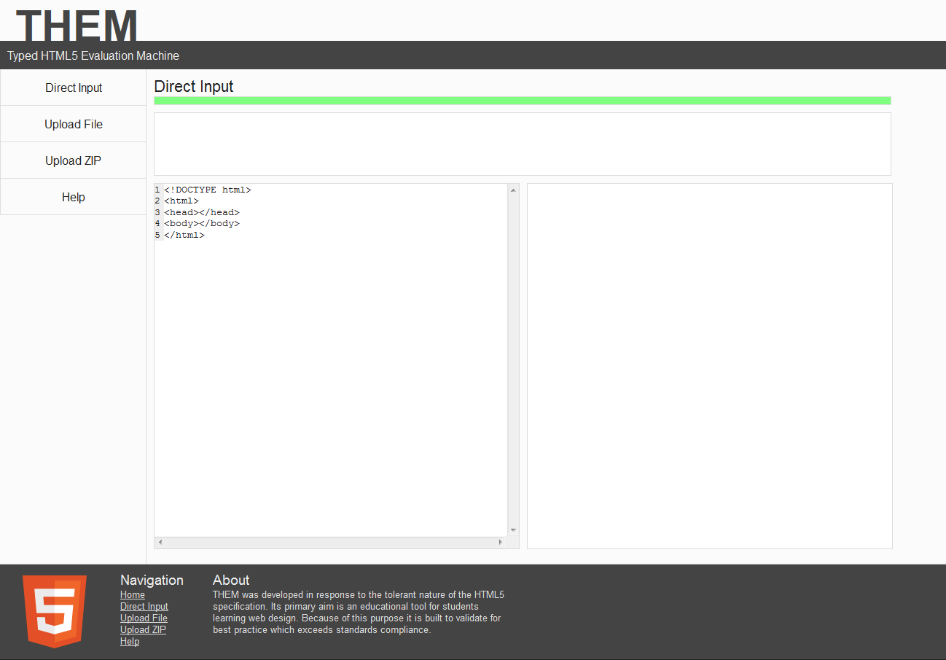
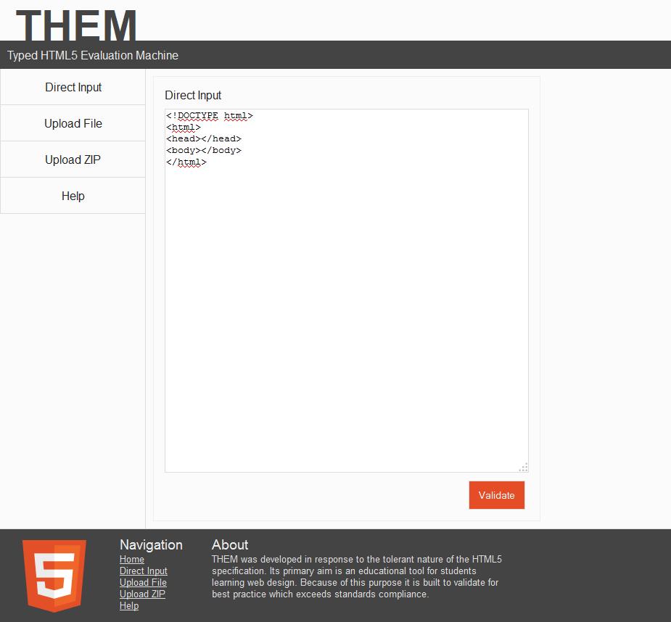
Direct Input
1. Navigate to Direct Input page.
2. Enter some HTML.
3. Click 'Validate'.
All good!

